Title or Task: | How Computers Work Solutions  

Description:

Files Required
Suitable for Classes: | All classes
Area: | Technology & Enterprise
Teacher: | Mr Peter Faulks

Timeline

Date Due:

Task Brief:

Outcomes:

ANSWERS



Worksheet

Task Brief: How Computer Components Work

- Go to the following site

http://computer.howstuffworks.com/hard-disk.htm
http://computer.howstuffworks.com/hard-disk.htm/printable

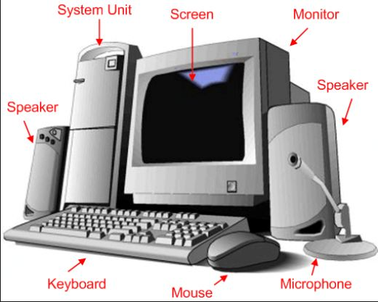
Motherboard -- The primary circuit board inside your PC is its motherboard. All components, inside and out, connect through the motherboard in some way. The other components listed on this page are removable and, thus, replaceable without replacing the motherboard. Several important components, though, are attached directly to the motherboard. These include the complementary metal-oxide semiconductor (CMOS), which stores some information, such as the system clock, when the computer is powered down. Motherboards come in different sizes and standards, the most common as of this writing being ATX and MicroATX.
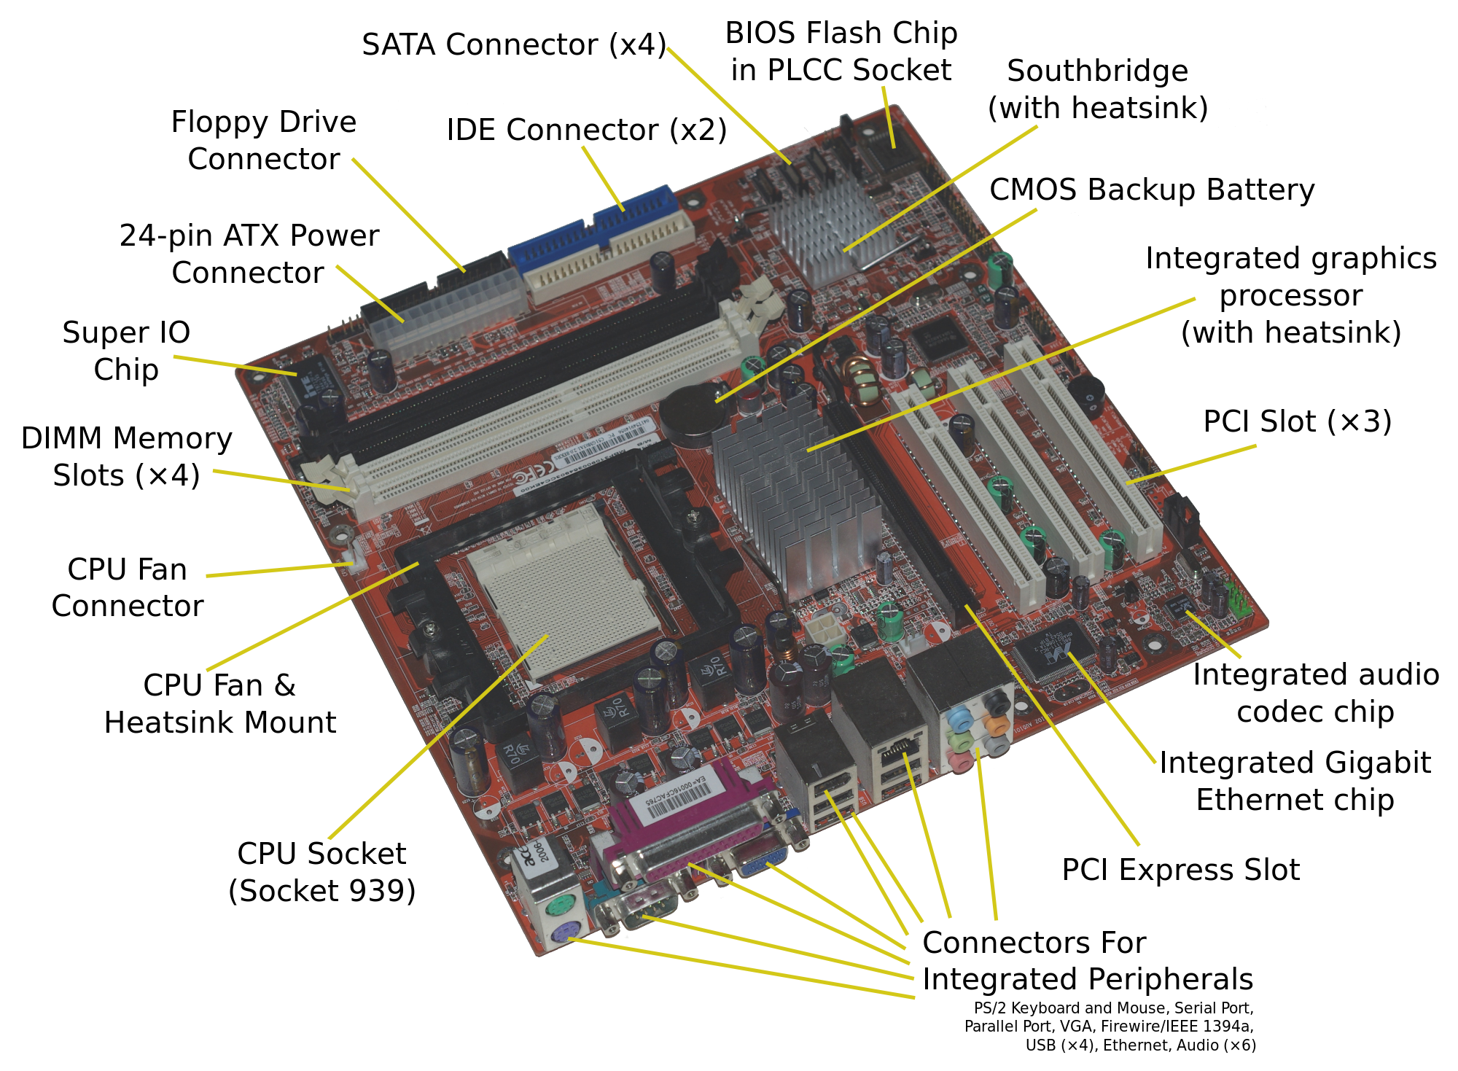
Label the parts of the Hard Disk Drive below at the end of the five pointers.(Easy)
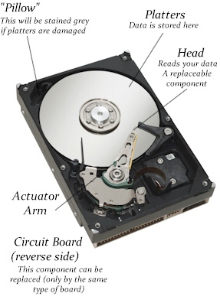
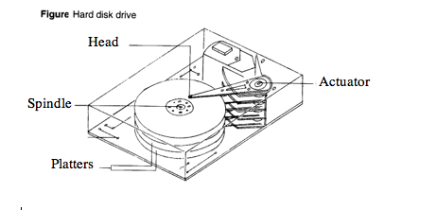

Label the parts of the Hard Disk Drive below at the end of all the pointers.(Not so easy)
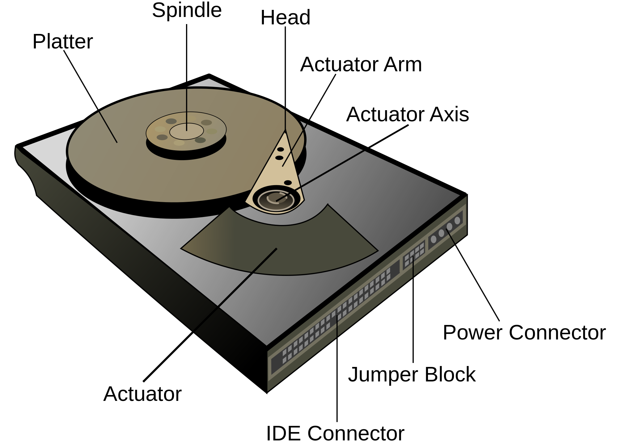

How the CD Rom Works
- Look at the following sites

http://computer.howstuffworks.com/cd.htm http://computer.howstuffworks.com/cd.htm/printable
http://howthingswork.virginia.edu/

- Label the following parts

- Look at more computer components such as the Floppy Drive and label the parts

A mouse is an input device that allows people to interact with their computer. There are two basic types, mechanical and digital.

Explain the difference between a mechanical (ball) mouse, and an optical mouse.

Explain the following mouse operations
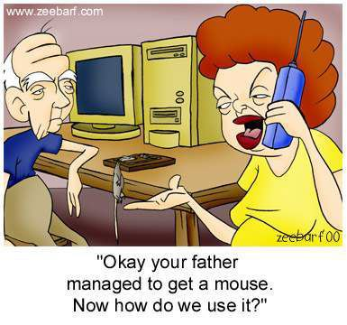

Left Click
A left click is the most frequently used click – it is simply a way of performing an ACTION wherever your mouse is pointing. In other words, a left click is saying “do this”. Some examples:-
- If your mouse is within a document in Word for example, then your cursor will simply move to the location your mouse is pointing
- If you are pointing at a “button” (like OKAY or CANCEL) then you press the button.
- If you are on a menu item then you select the menu option.
- If you are looking at a list of files/photos etc, a single left click may actually just select the file as you are saying “ACTION THIS FILE”. You then need to decide what you want to do with it
- If you see a “link” in internet explorer then clicking it will “open the new link”
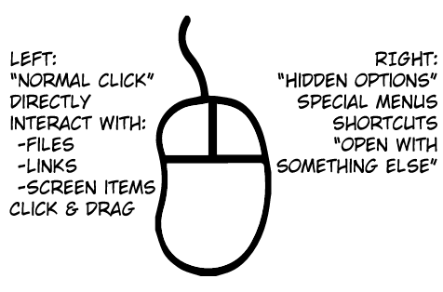

Right Click
A right click is really like asking “What can I do with this?”. By itself, generally, right clicking doesn’t actually do anything. If you right click “something” like a picture – you are actually asking “what can I do with this picture”. Typically a menu will appear showing you the possible options. If this happens, you would then move your mouse to the option you want and then LEFT CLICK to “DO” the action.
(So “right click” is asking “what can I do with this”. Then “left click” is telling it to “perform the action” you have chosen.
Examples
- Right click a file in “my documents” and you will see things you can do with that file, such as open, print, rename, delete etc
- Right click a word in Microsoft Word and you will see things you can do, such as copy, paste, paragraph settings etc

Double Click
Double clicking only happens with the left button. Generally as a new user you would only double click on things like your desktop icons, or files in your documents folder. Double clicking normally opens/runs the thing you clicked. Examples:-
- If you double click the Internet icon on your desktop, you open Internet Explorer
- If you double click a photo in “my documents”, you open the photo up in a photo viewer.

Scrolling (Mouse Wheel)
A mouse with a rubber or plastic wheel located between the left and right buttons (the "scroll wheel"). Also known as a "wheel mouse," when the wheel is moved back and forth, the active window is scrolled, eliminating the need to aim the pointer at the scroll bar.
Introduced in 1996, the scroll mouse is very useful for viewing long documents and Web pages, which have a vertical (portrait) orientation. Along with the regular left and right buttons, scroll mice may have side buttons that can be programmed for Previous Page, Next Page and other actions. In addition, the scroll wheel may move from side to side for horizontal scrolling. See touch scroll and scroll bar.
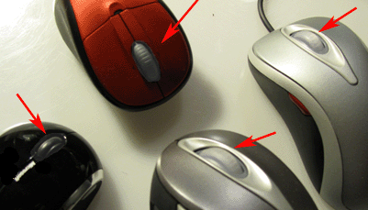

Dragging & Dropping

The basic sequence involved in drag and drop is:
- Move the pointer to the object.
- Press, and hold down, the button on the mouse or other pointing device, to "grab" the object.
- "Drag" the object to the desired location by moving the pointer to this one.
- "Drop" the object by releasing the button.

Moving & Text Selection
Holding the left mouse button down you can drag over text and with the button still down you can move the selected text to a new location.

Single selection of letters is select and drag
Double clicking on text word will select that word
Triple clicking will select a sentence or paragraph

Trivia - who invented the mouse?
A brilliant US computer scientist named Douglas Engelbart (1925–2013) invented the computer mouse.

Engelbart realized computers were far too useful just for boffins: he could see they had the power to change people's lives. But he could also see that they needed to be much easier to use. So, during the 1960s, he pioneered most of the easy-to-use computer technologies that we now take for granted, including on-screen word processing, hypertext (the way of linking documents together used in web pages), windows (so you can have more than one document or program in view at a time), and video conferencing.

But he's still best known for inventing the mouse, or the "X-Y Position Indicator" as it was originally known. That stuffy name was dropped when someone spotted that the cable hanging out looked just like a mouse's tail. From then on, Engelbart's invention was known simply as the "mouse".

Traditional Mouse (most were connected by PS2/ Serial plugs but today we use USB)
Traditional mice have a rubber ball inside them. Open one up and you can see the heavy ball clearly and the spring that keeps it in position.
Here's the inside of an old-style Logitech ball mouse: (I used to clean about 50 mouse balls a week - we removed the ball cleaned the inside and replaced the ball).
As you move it across your desk, the ball rolls under its own weight and pushes against two plastic rollers linked to thin wheels (numbered 6 and 7 in the photo). One of the wheels detects movements in an up-and-down direction (like the y-axis on graph/chart paper); the other detects side-to-side movements (like the x-axis on graph paper).
- Switch detects clicks of left mouse button.
- Switch for middle button.
- Switch for right button.
- Old-style connection to PS/2 socket on computer.
- Chip turns back-and-forth (analog) mouse movements into numeric (digital) signals computer can understand.
- X-axis wheel turns when you move mouse left and right.
- Y-axis wheel turns when you move mouse up and down.
- Heavy rubber wheel.
- Spring presses rubber ball firmly against X- and Y-axis wheels so they register movements properly.
- Electrolytic capacitor
- Resistors.

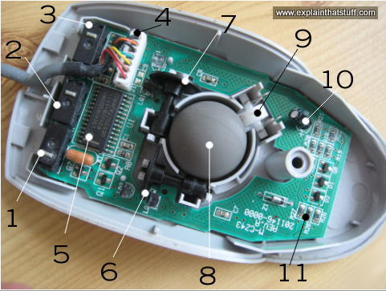

Optical mouse. An optical computer mouse uses a light source, typically an LED, and a light detector, such as an array of photodiodes, to detect movement relative to a surface. It is an alternative to the mechanical mouse, which uses moving parts to sense motion.

How an optical mouse works
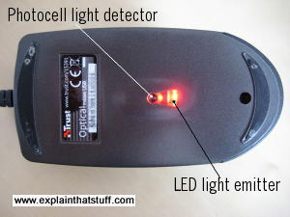
An optical mouse works in a completely different way. It shines a bright light down onto your desk from an LED (light-emitting diode) mounted on the bottom of the mouse. The light bounces straight back up off the desk into a photocell (photoelectric cell), also mounted under the mouse, a short distance from the LED. The photocell has a lens in front of it that magnifies the reflected light, so the mouse can respond more precisely to your hand movements. As you push the mouse around your desk, the pattern of reflected light changes, and the chip inside the mouse uses this to figure out how you're moving your hand.
Photo: An optical mouse seen from underneath. Note how the rubber ball you'd find in a ball-wheel mouse has been replaced by the photocell and LED.
Some optical mice have two LEDs. The first one shines light down onto the desk. The light from that is picked up by the photocell. The second LED lights up a red plastic strip along the back of the mouse so you can see it's working. Most optical mice also have a wheel at the front so you can scroll pages on-screen much faster. You can click the wheel too, so it functions like the third (center) button on a conventional ball mouse.
Photo: An optical mouse seen from underneath. Note how the rubber ball you'd find in a ball-wheel mouse has been replaced by the photocell and LED.
Some optical mice have two LEDs. The first one shines light down onto the desk. The light from that is picked up by the photocell. The second LED lights up a red plastic strip along the back of the mouse so you can see it's working. Most optical mice also have a wheel at the front so you can scroll pages on-screen much faster. You can click the wheel too, so it functions like the third (center) button on a conventional ball mouse.
An optical mouse is much more hi-tech than a ball mouse. Where a ball mouse has quite a few moving parts, an optical mouse is almost entirely electronic (it has almost no moving parts).
Here's the inside of a typical optical mouse and a few of the main components. The most interesting bits are in the center (where the LED light shines down onto your desk) and at the front (where button presses are detected by switches):
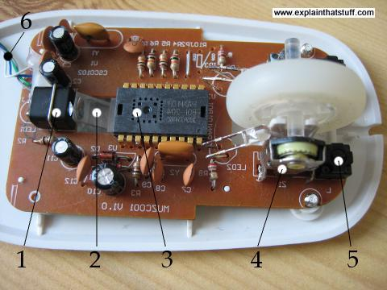
- An LED at the back generates red light and shines it horizontally, from the back of the mouse toward the front (from the left to the right of this photo).
- A plastic light guide channels the light from the LED at an angle, down onto the desk.
- A light-detector chip measures light reflected back up from the desk, converting the analog movements of your hand into digital signals that can be sent to your computer.
- The scroll wheel at the front of the mouse is mounted on a switch mechanism that detects both how much it's rotated and whether you've pressed it (it functions like the central button of a conventional mouse). Rotations of the scroll wheel can be detected in a variety of different ways. Some mice use potentiometers (broadly, variable resistors), similar to the volume control on a radio but able to turn around multiple times. Others use various kinds of rotary switches or optical (rotary) encoders to convert analog wheel movements to digital signals.
- A microswitch detects when you press the right mouse button. There's an identical switch on the other side to detect the left mouse button.
- The USB cable connection carries digital information from the mouse to your computer.

- Give the name for each of the following symbols in Logical Data Flow Diagrams

(I) Function (II) Input/Output (III) Flow (IV) File/Database

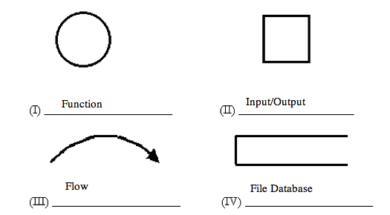
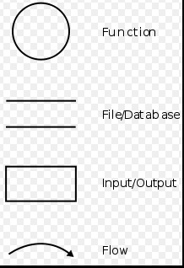

What ports are available for attaching external devices to computers?
ports are available for attaching external devices.

Serial (several types) - Mouse, keyboard, printer…
USB
3.5mm Audio
Ethernet
VGA
Optical
HDMI
Display

Any will do but minimum should be 4

http://www.labnol.org/gadgets/visual-guide-to-computer-cables-connectors/10694/

